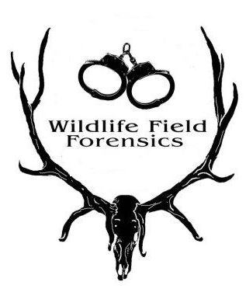
PO Box 49, Seeley Lake, MT 59868 406-677-7007

REGISTRATION
Wildlife Field Forensics Seminar
9-11 May 2023

Contact: Carleen Gonder 406-677-7007 carleen_montana@yahoo.com
PO Box 49, Seeley Lake, MT 59868

Name________________________________________________________________________________
Address_______________________________________________________________________________
E-mail__________________________________Phone, circle one: home, work, cell___________________
Agency____________________________________Position_____________________________________
………………………………………………………………………………………………………………..

Fee for the seminar – $775.00 (US dollars)*

*Includes a binder of course materials, refreshments during breaks and a box lunch for the field day
~~~ All attendees will receive a free t-shirt ~~~

Participants are responsible for their own lodging and meals
Recommendations will be provided

Please make checks payable to: Wildlife Field Forensics
Mail checks and completed registration form to the above address.
Please call for the EIN and DUNS number if needed.

~ SEMINAR SPACES FILL QUICKLY ~

PLEASE REGISTER BEFORE 1 March 2023
SEMINAR SPACE IS LIMITED TO 45 PARTICIPANTS
(Registration deadline can be extended for a limited time.)

REFUND POLICY:
Full refunds available for cancellations prior to 1 March 2023
Half of the registration fee refunded for cancellations between 1 March & 15 March
No refunds after 15 March 2023

<’}}}}><{ ~~~~~~~~~~ <’}}}}><{ ~~~~~~~~~~~ }><{{{{‘> ~~~~~~~~~~ }><{{{{‘>

The May 2023 seminar will be held at the Seeley Lake Community Center
Seeley Lake is approximately 55 miles from the Missoula, MT airport.

